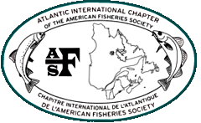
36th Annual Meeting
Atlantic International Chapter
September 19 – 21, 2010
Stanhope Inn, PEI

Sunday, September 19th
3:00 pm - 7:00 pm | Registration
Sunday Evening Session (and Mixer) | Moderator: Ernie Atkinson- Maine Bureau of Sea-Run Fisheries & Habitat
7:00 pm - 8:30 pm  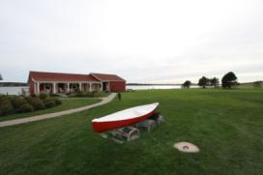 | Chris Connell and Chad Doherty- Development of standardized electronic data collection tools, methodologies, and database
 | Randy Spencer- Migratory behavior and spawning activity of adult sea-run Atlantic salmon
 | Joan Trial- Update on Atlantic Salmon in Maine
 | Phil Downey- What lurks under the city? Sampling the partially enclosed Park River, Hartford, CT, USA.
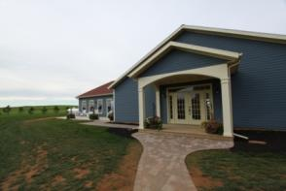
Open Microphone - Informal Presentations of what you have been working on….
8:30 pm - 10:00 pm | Social - Gahan Brewery Beer on Tap
Monday, September 20th
7:00 am - 8:00 am | Breakfast
8:15 am - 8:30 am | Welcome and Introductions
8:30 am - 9:00 am | Keynote Speaker: Fred Whoriskey- Past, present, and future of Sonic Telemetry Networks
9:00 am - 9:10 am | Coffee Break

Salmonid Studies | Moderator: Joan Trial- Maine Bureau of Sea-Run Fisheries & Habitat
9:10 am - 9:30 am | Rosalyn Smedley-An overview of the Atlantic Salmon Conservation Foundation
9:30 am – 9:50 am | Graham Goulette- Efficacy of CWTs for Stocking Identification in Atlantic salmon Parr
9:50 am - 10:10 am | Jud Kratzer- Study design for salmonid sampling in Vermont’s rivers how many years and which variables?
10:10 am - 10:30 am | Ernie Atkinson-A Brief History of Old Stream or How Doing Nothing can be the Best Strategy
10:30 am - 10:40 am | Coffee Break
Fish Communities and Production | Moderator: Graham Goulette- NOAA Fisheries
10:40 am - 11:00 am | Kaitlyn Koch-An assessment of the ichthyoplankton communites in the lower Thames River, Groton, CT.
11:00 am – 11:20 am | Heather McCracken-The influence of food energy from headwater lakes on downstream communities
11:20 am - 11:40 am | J. Mark Hanson- The ecosystem continuum: quantifying the structure of the coastal Zone l. Northumberland Strait
11:40 am - 12:00 pm | Murray Somers- Developing a model for brook trout production in New Brunswick streams
12:00 pm - 1:30 pm | Lunch
Fish Passage and Management | Moderator: Kathryn Collet- New Brunswick Dept. of Natural Resources-Fisheries
1:30 pm - 1:50 pm | Steve Shepard- American Shad Passage and behavior at Lockwood Dam, Kennebec River, Maine
1:50 pm - 2:10 pm | John Magee- Fish Passage May Lead to More Resident Fish
2:10 pm - 2:30 pm | Katrina Mueller-Cooperative Conservation in Action: Project SHARE's on-the-ground habitat restoration program
2:30 pm - 2:50 pm | Ben Naumann- Evaluation of changes in physical habitat from stream connectivity restoration efforts in Downeast Maine
2:50 pm – 3:10 pm | Joan Trial- An international boundary fish’s tale
3:10 pm – 3:30 pm | Break

Angler Survey Forum | Moderator: Christine Lipsky- NOAA Fisheries
3:30 pm - 5:15 pm | Panel Discussion: Chris Connell (NB), Joan Trial (ME), John Magee (NH), Al McNeill (NS), Jud Kratzer (VT), Rosie MacFarlane (PEI)
5:15 pm – 5:30 pm | Poster session set-up
Poster Session
5:30 pm – 7:00 pm | Barbara Arter - Penobscot River Science Exchange: A Consortium for Dam Removal and Diadromous Fish Restoration Research
5:30 pm – 7:00 pm | Daniel Skall - Fish Scales as non-lethal biosensors of contaminants in surface waters: preliminary findings
7:00 pm – 8:00 pm | Dinner
Tuesday, September 21st
7:00 am - 8:00 am | Breakfast
8:00 am – 8:20 am | Scott Craig – Results from online membership survey
8:20 am - 10:20 am | BUSINESS MEETING
Striped Bass | Moderator: Scott Craig – USFWS Maine Fishery Resources Office
10:20 am - 10:40 am | Jeremy Broome- Tagging, Tracking, and Tidal Power: Striped Bass in Minas Passage, NS
10:40 am - 11:00 am | Trevor Avery-Using Local Ecological Knowledge for Striped Bass Assessment, Management and Stewardship
11:00 am - 12:00 pm | RAFFLE AND FISHING CONTEST AWARDS AND WRAP UP
12:00 pm - 1:30 pm | Lunch

Sunday Evening Session (and Mixer)
Moderator: Ernie Atkinson- Maine Bureau of Sea-Run Fisheries & Habitat

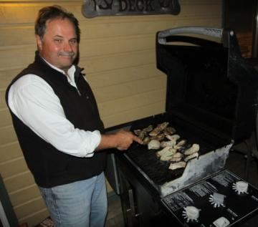
Title: Migratory behavior and spawning activity of adult sea-run Atlantic salmon translocated to novel upriver habitat within the Penobscot Basin, Maine.

Primary Author:
Randy Spencer
Maine DMR, Bur Sea Run Fishereis and Habitat
650 State Street
Bangor, ME 04401
randy.spencer@maine.gov

Contributors:
Justin Stevens, Denise Buckley

Translocation of pre-spawn Atlantic salmon into headwater habitat was evaluated as a method of circumventing upstream migratory losses and promoting spawning in the most productive rearing habitats. Sea-run salmon (57 female, 47 males) returning to the Penobscot River were captured in May and June, 2009 at a fishway trap and held at a freshwater hatchery. Fish identifiable (by tags and marks) as returns from hatchery smolts stocked at a site outside the study area were used exclusively to ensure a uniform imprinting history in study animals. On 5 October 2009 the salmon were trucked 152km upstream (above seven dams) and released in the study area at Abbot. Twenty nine of the female salmon were radio-tagged to monitor post release movements and redd counts were conducted to assess spawning activity. Sixty one redds were observed in the study area, of which 75% were assigned to translocated females based on the distribution of radio tagged fish. Of the 600 non-translocated, free-swim females trapped and released in the lower Penobscot River (at Veazie and Greenbush), eight (1.3%) spawned in the study area compared to 26 (45.6%) of the translocated females. Other translocated females (28%) homed rapidly to their original smolt release site 145km downriver and remained there (within 4.2 km mean) through spawning. The translocated adults produced a threefold increase in natural spawning in the prioritized habitat relative to free-swim females released in the lower river.

Title: What lurks under the city? Sampling the partially enclosed Park River, Hartford, CT, USA.

Primary Author:
Philip Downey
Aquatec Biological Sciences, Inc.
273 Commerce Street
Williston, VT 05495
pdowney@aquatecb.com

Contributors:
Kaitlyn Koch, John Williams and Stuart Randall.

The Park River flows for approximately two miles in two concrete culverts under Hartford, Connecticut. In the north culvert, a thermal discharge of heated water is located about 1400 feet upstream of the confluence with the Connecticut River. Electrofishing surveys of the fish communities in both culverts were conducted during four seasons. During several seasons, fish community composition differed between the two culverts.
___________________________________________________________________________________
Salmonid Studies
Moderator: Joan Trial- Maine Bureau of Sea-Run Fisheries & Habitat

Rosalyn Jud Joan Ernie Graham
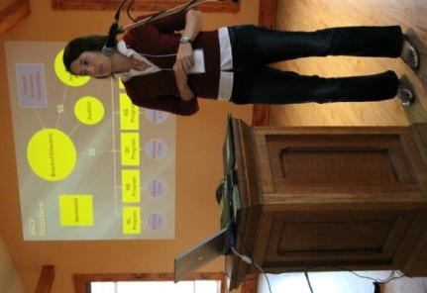

Title: An overview of the Atlantic Salmon Conservation Foundation

Primary Author:
Rosalyn Smedley
The Atlantic Salmon Conservation Foundation
480 Queen Street, Suite 200
Fredericton, NB E3B 1B6
roz@salmonconservation.ca

Contributors:
Stephen Chase

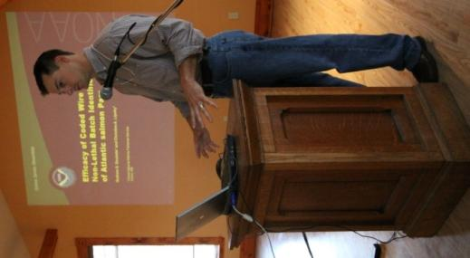
An overview of the Foundation, including the origins of the foundation, how it is structured and it's mission. Also, examples of projects that are funded and how to apply

Title: Efficacy of Coded Wire Tags for Non-Lethal Batch Identification of Atlantic salmon Parr

Primary Author:
Graham Goulette
NOAA
17 Godfrey Drive
Suite 1
Orono, ME 04473
Graham.Goulette@noaa.gov

Contributors:
Christine Lipsky NOAA
Hatchery products are a valuable component to the Atlantic salmon (ATS) recovery program in the Penobscot River, Maine. Several stocking methods including fry stocking, parr stocking and smolt stocking are used to recover ATS populations. Correct identification of the rearing origin of returning adults is vital to assess the contribution of each method to overall ATS recovery. We investigated the use of Coded Wire Tags (CWTs) in various body locations of ATS parr to determine if the tags could be used as a non-lethal batch identifier during recovery. We used parr being held at the USDA ARS Cold Water Marine Aquaculture Center in Franklin, Maine to determine our ability to identify batches with different CWT locations. All study fish were previously marked by USDA with a PIT tag so all individuals were traceable. We tagged groups of 50 ATS parr in four different body locations using Northwest Marine Technology (NMT) handheld multi-shot injectors and an additional 51 non-tagged parr from the same stock were used as a control and held in common tanks. We examined fish for tags at 6, 21 and 28 months using an NMT wand detector and monitored individual identity using PIT information. We monitored tag retention, correct identification of location, and growth rates for all tagged groups and growth rates for the control group. Tag retention was 94.5% at the final check. Identification of tag location improved with each check to 87.7% at 28 months. Growth rates between tagged and control groups were similar (ANOVA p = 0.0487). Furthermore, we believe tag retention and correct identification would improve with the use of automated MARK IV tagging machines to remove operator error of the hand held units.

Title: Study design for salmonid sampling in Vermonts rivers how many years and which variables?
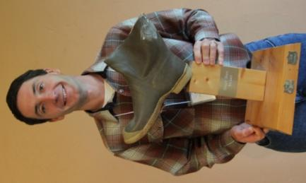
Primary Author:
Jud Kratzer
2010 Soggy Boot
Award Winner
Beaver Trout-Charr

Vermont Fish and Wildlife Department
1229 Portland St., Suite 201
St. Johnsbury, VT 05819
jud.kratzer@juno.com

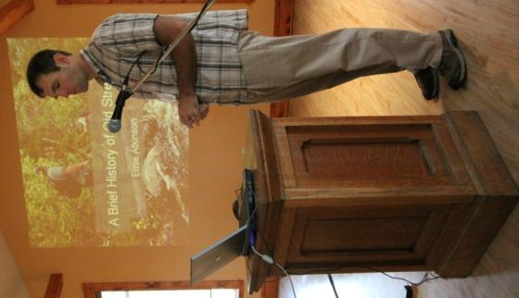
Fisheries biologists sample salmonid populations in rivers and streams for many reasons, including estimating smolt production, evaluating the effects of habitat improvement efforts, evaluating and adjusting trout stocking rates, and long term monitoring of salmonid populations. A major challenge in sampling salmonid populations is to accurately characterize the population given the large annual variation that occurs naturally. The purpose of this study was to determine the minimal number of years a reach must be sampled and the best variables to use in order to characterize the population with narrow confidence intervals and high statistical power. We analyzed data collected by the Vermont Fish and Wildlife Department over 10-27 years from 26 streams with wild reproduction of trout and over 6-25 years from 67 streams where Atlantic salmon fry are stocked. We determined that a reach must be sampled at least four to six years for the data to have meaningful confidence intervals and statistical power, whether or not a Before-After-Control-Impact (BACI) study design is utilized. Narrower confidence intervals and higher power were obtained with biomass rather than number estimates, and including young-of-the-year salmonids in population estimates resulted in narrower confidence intervals and higher power than when they were excluded.
________________________________________________

Title: A Brief History of Old Stream or How Doing Nothing can be the Best Strategy

Primary Author:
Ernest Atkinson
ME-DMR Bureau of Sea-run Fisheries and Habitat
P.O. Box 178
317 Whitneyville Road
Jonesboro, ME 04648
ernie.atkinson@maine.gov

Old Stream is a highly productive cold water tributary to the Machias River located in Washington County, Maine. The Machias River is within the Gulf of Maine Distinct Population Segment for endangered populations of Atlantic salmon (Salmo salar) listed under the US Endangered Species Act. Among these drainages, Old Stream is a bright point. Annual escapement to Old Stream has been high; around 30 adults annually. Juvenile densities are among the highest in the Downeast SHRU and there is strong evidence suggesting that juvenile production is positively related to natural escapement rather than through hatchery related strategies such as fry stocking.
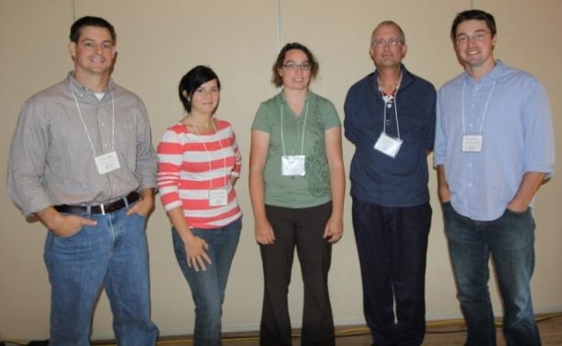
Graham Heather Kaitlyn Mark Murray
Fish Communities and Production

Moderator: Graham Goulette-
NOAA Fisheries

Title: An assessment of the ichthyoplankton communites in the lower Thames River, Groton, CT

Primary Author:
Kaitlyn Koch
Aquatec Biological Sciences, Inc.
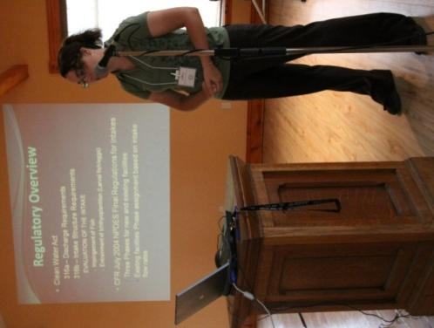
273 Commerce Street
Williston, VT 05495
kkoch@aquatecb.com

Contributors:
Philip C. Downey, John Williams and Stuart Randall.

The seasonal distribution and density of larval fish are important factors affecting the potential entrainment of ichthyoplankton species. An assessment of entrainment of larval fish and eggs and their potential effect on an adjacent fish community was required by regulatory agencies. A year-long study was conducted to document the ichthyoplankton community (eggs and larval stages) of the Thames River adjacent to a saltwater intake. Individuals were identified using standard microscopic and photographic techniques for identification. In the lower Thames River, winter flounder (Pseudopleuronectes americanus), a commercially and recreationally important species, was the primary species of investigation. Seasonal distribution of common species encountered and the generalized approach assessing standardized adult equivalent losses will be discussed.
Title: The ecosystem continuum: quantifying the structure of the coastal zone I. Northumberland Strait

Primary Author:
John Mark Hanson
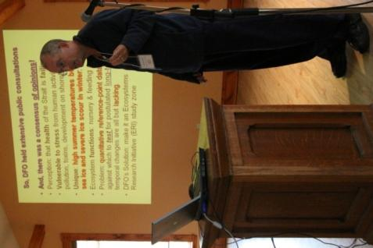
Fisheries & Oceans Canada
Gulf Fisheries Centre
P. O. Box 5030
Moncton, NB EiC 9B6
mark.hanson@dfo-mpo.gc.ca

Northumberland Strait (you crossed over it to get here) is a stressed coastal ecosystem; however, a dearth of quantitative studies has resulted in the lack of baseline data against which to test for improvements or decline in ecosystem health. An ambitious four-year research plan (The Northumberland Strait Ecosystems Research Initiative) has been developed to quantify the structure of this highly dynamic water body beginning with identification of water masses and currents and progressing through to fishes and large decapod crustaceans. In the first phase, numerical models of movements of water and sediments are being developed and tested empirically using newly-developed MAPs technology. Aggregate biomass models (e.g., spatially explicit nutrient and biomass pools, size-spectra, biodiversity measures, pelagic and demersal food web) are being developed to describe the mass and flux of nutrients and energy in the Strait for both the pelagic and demersal energy cycles (including potential coupling). The eventual goal is to develop full ecosystem-level models (e.g., mass-balance and nutrient loading/flux) for use in integrated management programs based largely on the information gathered in this project

Title: The Influence Of Food Energy From Headwater Lakes On Downstream Communities

Primary Author:
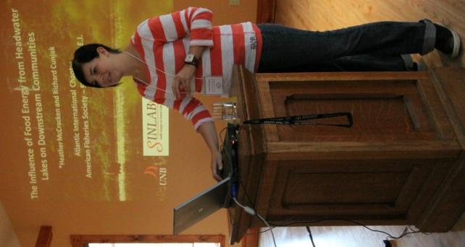
Heather McCracken (Student)
CRI-DNR-UNB
1350 Regent St
Fredericton, NB E3B 3Z4
heather.mccracken@gnb.ca

Contributors:
Richard Cunjak

Using carbon and nitrogen stable isotope analysis, our research aims to determine how food webs in shallow headwater lakes contribute energy to downstream communities. During spring and summer of 2008/2009 organisms (primary producers to secondary consumers) were collected from 3 lakes and their outflow streams in New Brunswick, Canada. Data were analysed using a one isotope, two-source mixing model to determine contributions of nutrient sources and graphically represented in δ13Cvs.δ15N bi-plots. Lake data indicate the diet of adult cyprinid and salmonid fishes (δ13C=-27.23, -25.04) was predominantly littoral algae-grazing invertebrates (δ13C=-27.71). In comparison, isotopic values of juvenile conspecifics (δ13C=-32.33) suggested a food source based on pelagic algae (δ13C =-34.48) during spring when phytoplankton was abundant. By summer, juvenile fishes showed a dietary shift (δ13C =-29.87) suggestive of a littoral food source. Simuliid larva isotope values (δ13C=-32.77) indicated a downstream lacustrine influence when compared with autochthonous carbon sources (δ13C=-27.42) at 0.5km from the lake. In 2009, we focused our efforts farther downstream (up to 3km) to determine reach of lacustrine influence. These results, along with other spatial comparisons, will be presented.
_______________________________________________
Title: Developing a predictive model for brook trout (Salvelinus fontinalis) production in New Brunswick streams

Primary Author:
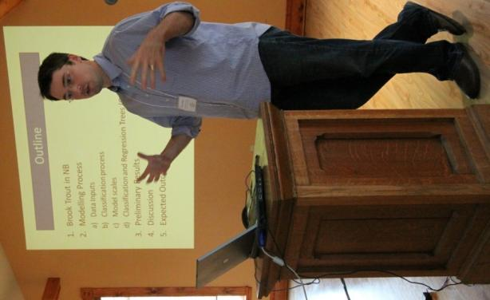
Murray Somers (Student)
Canadian Rivers Institute / University of New Brunswick
1097 McLeod Hill Rd
McLeod Hill, NB E3G 6J1
murray_somers@theedge.ca

Contributors:
Dr. Allen Curry

The brook trout (Salvelinus fontinalis) is a widespread and highly valued fish species in New Brunswick. It is well known that brook trout require specific in-stream habitats in order to thrive, e.g., cool, clean water, however we are just beginning to understand the importance of surrounding landscape factors that can impact in-stream habitats. By organizing landscape, habitat, and brook trout metrics in to a common database, we can use a classification and regression tree (CART) statistical analysis to identify a set of metrics that best explain the different characteristics of brook trout status, e.g., relative abundance, condition factor. This predictive model will be tested to determine its effectiveness at predicting brook trout production. In addition, the model will indicate the factors that may regulate brook trout production as well as tolerance thresholds. The impact of the model will be important in managing brook trout in New Brunswick as it can be used to identify the predicted status of a stream system and thus help direct management decisions, e.g., healthy brook trout population or below expected capacity.

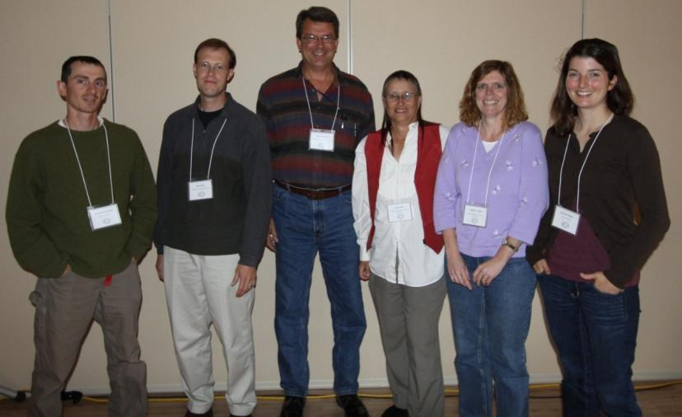
Ben John Steve Joan Kathryn Katrina
Fish Passage and Management

Moderator:
Kathryn Collet-

New Brunswick Dept. of Natural Resources-Fisheries

Title: American Shad Passage and Behavior at Lockwood Dam, Kennebec River, Maine, USA

Primary Author:
Steve Shepard
Aquatic Science Associates, Inc.
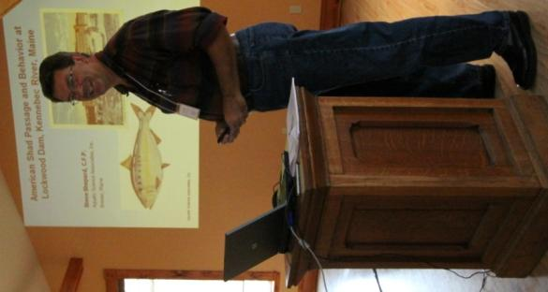
P.O. Box 775
Brewer, ME 04412
asa@rivah.net

Radio telemetry methods were used to study American shad passage at Lockwood Hydroelectric Project on the Kennebec River in Maine. The Project is now the first dam encountered by anadromous fish since the Edwards Dam was removed from a head-of-tide location about 34 km downstream. The Project includes a new fish lift that was installed for river herring, Atlantic salmon and American shad. Underwater video monitoring has demonstrated that the lift effectively passes river herring and salmon. However, very few American shad approach the fishway entrance and few have been passed. Thirty American shad (14 male, 16 female) were caught on rod and reel and radio tagged near the start of the spawning migration in 2009. Radio receivers and automated data loggers were installed and tuned to continuously monitor radio tagged shad presence at seven locations; the fish lift entrance, the fish lift hopper, outside the entrance, the powerhouse tailrace, two locations in the 300m long bypass reach, and 2.7km downstream of the powerhouse. Frequent mobile tracking by vehicle, boat and airplane supplemented the data logger contacts. Tagged shad were typically found near their original capture location during daylight, dropped downstream a short distance to a spawning location near dusk, and returned to the capture area near dawn. Shad were also found at a location about 2.5km downstream of the dam. Two (6.7%) of 30 shad approached the fish lift. One entered the fish lift two days after release at 20:07 and remained in the hopper for 59 minutes, although it was not lifted since it was after normal operating hours. A second shad approached the lift entrance for several minutes the day after release, but did not enter the fishway. Four tagged shad approached the bypass reach and two (6.7%) of these shad moved upstream where they were logged for more than an hour on the upper bypass reach data logger before leaving. Very high flows in late June and July 2009 were associated with the downstream movement of radio tagged shad. Aerial tracking in tributaries and downstream to the estuary demonstrated that tagged shad that left the study area generally returned to marine environments. Three shad that were contacted while emigrating from the river had minimum rates of movement of 49, 54 and 108 km/day, respectively. Two shad returned from marine environments after absences of five and 11 days, and two more returned after five and six days in the tributary Sebasitcook River. These data demonstrate that tagged shad were not generally approaching the fish lift. Most tagged shad were holding and spawning at specific locations downstream of the project and did not appear to migrate further upstream. Migration cessation may be related to imprinting on downstream spawning location(s), density dependent spawning dynamics, presence of large striped bass in the study area, fishway attraction problems, tailrace hydraulics or other issues. The hydraulics of the fishway entrance and tailrace were investigated in a subsequent study.

Title: Fish Passage May Lead to More Resident Fish

Primary Author:
John Magee
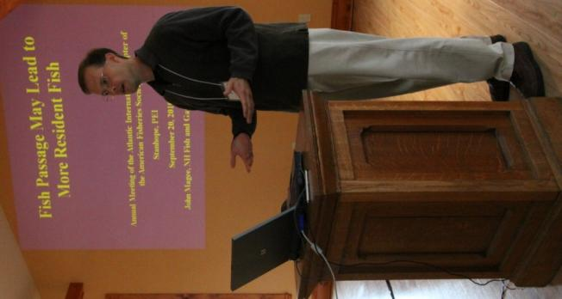
NH Fish and Game Department
11 Hazen Drive
Concord, NH 03301
john.a.magee@wildlife.nh.gov

Contributors:
Ben Letcher, Meredith Bartron

Beginning in 2007, we have inserted PIT tags into brook trout in four streams at Nash Stream State Forest in New Hampshire. During the study, on two of these streams, culverts that were severe barriers to upstream movement by brook trout were replaced with crossings that are not barriers to movement. On one stream, a moderate barrier was replaced, and on the fourth stream, there are no barriers to the study area. We found that the population of wild brook trout in the summer in the two streams with the most severe barriers, upon removal of the barriers, increased more so than for the other two streams. This study will continue for at least another year, at which time we will learn more about how the removal of movement barriers influences populations of wild brook trout

Title: Cooperative Conservation in Action: Project SHAREs on-the-ground habitat restoration program
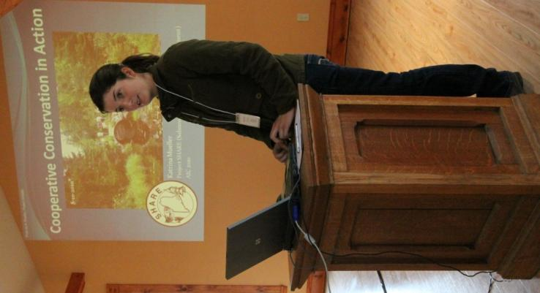
Primary Author:
Katrina Mueller
Project SHARE
249 Potter Rd
Hudson, ME 04449
mueller.katrina@gmail.com

Project SHARE, a 501(c)(3) organization, has developed an active on-the-ground program that restores fish passage and natural stream function at a landscape scale to benefit native sea-run and resident fishes, including Atlantic salmon and Eastern brook trout. Specifically, SHARE works cooperatively with landowners, state and federal agencies, universities and other stakeholders to identify regional threats and conservation priority areas, address all site-specific issues affecting fish passage and natural stream processes within those areas, monitor restoration outcomes, and engage students and professionals in hands-on learning opportunities. Based on the regional threats assessment, SHAREs primary restoration focus is currently the decommissioning or replacing of traditional round culverts with open bottom structures designed to accommodate natural stream processes and fish passage. At the end of 2010, approximately 100 of these structures will have been corrected in a concentrated area. Other restoration activities include the placement of large wood to increase habitat complexity, removal of remnant log-drive dams to correct hydrology, and planting of native trees to increase shade along restored reaches. In addition to increasing the number of critical habitat units available to Atlantic salmon in the Downeast Salmon Habitat Recovery Unit, these activities are increasing access and availability of suitable fry stocking sites. Further, SHARE is implementing a large-scale and multi-layered monitoring effort that not only evaluates how headwater streams respond to restoration, but also how important these systems are to juvenile Atlantic salmon.

Title: Evaluation of changes in physical habitat from stream connectivity restoration efforts in Downeast Maine

Primary Author:
Benjamin Naumann
Project Share
15 South Gouldsboro Road
Gouldsboro, ME 04607
bnaumann_lw@yahoo.com
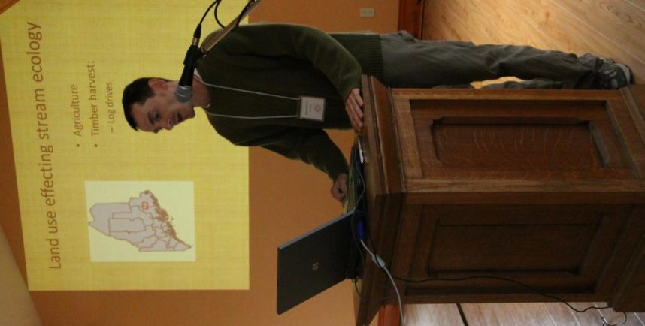
Contributors:
Scott Craig, Steve Koenig

In recent years, a boom of stream conductivity restoration projects have taken-place for streams degraded by roads. However, little has taken place to assure these projects are increasing physical habitat for target species. In 2009, 35 stream road crossing conductivity projects were completed on the Machias River (Downeast Maine) utilizing open bottom arch culverts and road decommissions. To evaluate changes in physical habitat, pre and post construction assessments were carried out using habitat suitability indices (HSI) for brook trout (Salvelinus fortinalis) and Atlantic salmon (Salmo salar). Depth, substrate size, and velocity were used as variables to evaluate changes in physical habitat for juvenile Atlantic salmon. Adult brook trout habitat was compared from the following variables; depth, percent pool, and pool rating class. Observationally, project sites have improved, reducing stream width, increasing flow, and reducing fine sediment. Quantitative analysis will be conducted in the fall of 2010. Increases in HSI scores would provide evidence of the effectiveness of stream conductivity restoration projects in improving brook trout and Atlantic salmon habitat.

Title: An International Boundary Fishes' Tale

Primary Author:
Joan Trial
ME-DMR Bureau of Sea-run Fisheries and Habitat

650 State Street
Bangor, ME 04401
Joan.Trial@maine.gov

The fishes are alewife (gaspereau) and smallmouth bass, the International Boundary is between the United States (Maine) and Canada (New Brunswick), and the tale is about a proposed adaptive management plan. Advocates who believed alewife caused declining numbers of juvenile smallmouth bass and poor quality bass angling in Spednic Lake worked to have the Maine Legislature prohibited alewife passage on the St. Croix River. The 1995 law resulted in blocking alewife at the Woodland and Grand Falls fishways, thus preventing access to over 98% of their spawning habitat in the watershed. The stock declined from 2.6 million returning alewives in 1987 to only 900 in 2002. Advocates for the alewives failed in a 2001 effort to change the law blocking alewife from the St. Croix failed. A renewed effort in 2008 resulted in restoring alewife passage at the Woodland Dam only. In spring 2009, a group of conservation organizations petitioned the United States/Canada International Joint Commission to re-open all of the St. Croix's boundary dam fishways to alewife passage under the auspices of the 1909 Boundary Waters Treaty. The International Joint Commission’s International St. Croix River Watershed Board requested that an ad hoc group of fisheries biologists develop an adaptive process for restoring alewife (gaspereau) to the St. Croix watershed while maintaining the smallmouth bass fishery at current or higher quality. Based on the charge from the Board, biologists from Maine (Departments of Marine Resources and Inland Fish &Wildlife), New Brunswick (Department of Natural Resources), U.S. Fish and Wildlife Service, National Oceanic and Atmospheric Administration Fisheries Service, and Fisheries and Oceans Canada compiled and analyzed data and used consensus to develop a plan. It calls for opening access to a portion of the watershed, tracking alewife population recovery, and monitoring juvenile smallmouth bass production. Annual alewife escapement targets at the lower dam will be set based on the three year running averages of alewife population size and of an index of juvenile bass production success.

Angler Survey Forum Panel Discussions
Moderator:
Christine Lipsky- NOAA Fisheries
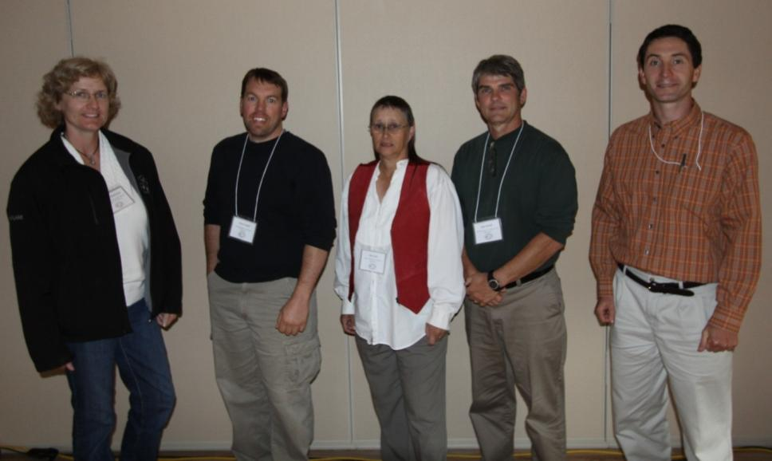
Rosanne Chris Joan Al Jud


Jeremy Trevor

Striped Bass
Moderator: Scott Craig –
USFWS Maine Fishery Resources Office

Title: Tagging, Tracking, and Tidal Power: Striped Bass in Minas Passage, NS.

Primary Author:
Jeremy Broome (Student)
Acadia Center for Estuarine Research
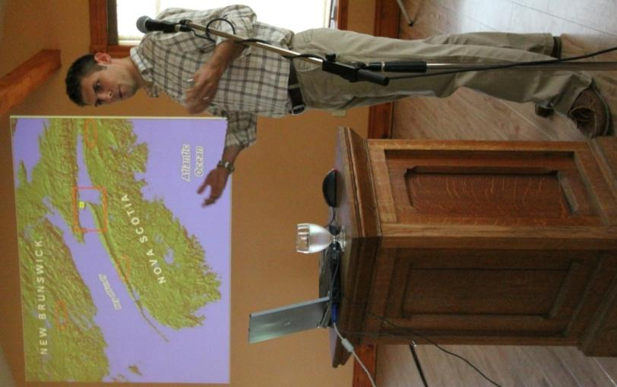
BOX 115 Acadia University
23 Westwood Ave.
Wolfville, NS B4P 2R6
071446b@acadiau.ca

Contributors:
Anna Redden, Rod Bradford, Michael Stokesbury

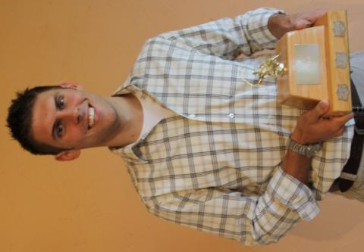
The status and composition of striped bass stocks within the Bay of Fundy, Canada is currently debated and ultimately not well understood. Native stocks are currently designated by COSEWIC as threatened or reproductively extinct. Renewed interest in harnessing tidal energy from Minas Passage, Bay of Fundy using in-stream tidal turbines presents an unknown risk to striped bass and other fish species known to utilize this area. However, the factors making the area suitable for tidal power extraction, such as strong tidal currents (up to 6 m/sec), turbulent flow and a tidal range in the Minas Basin in excess of 15m, also present significant operational and logistical challenges for environmental effects monitoring studies. The objectives of this project are to gain an understanding how striped bass move, feed, and behave within the tidal power test area, and to determine the level of potential impact that may be posed by the installation and operation of in-stream tidal power turbines. VEMCO (Halifax, NS) acoustic telemetry technology will serve as a primary platform with which to assess the severity and likelihood of potential fish-facility interactions. Additionally, traditional tagging methods, and population sampling will serve to augment acoustic telemetry data. This presentation will outline the progress to date of our current research program, as well as highlight the challenges associated with working in such an extreme environment.

2010 Lunker Award- Blue Shark

Title: Using Local Ecological Knowledge for Striped Bass Assessment, Management and Stewardship

Primary Author:
Trevor Avery
Acadia University
Department of Biology
33 Westwood Ave.
Wolfville, NS B4P2R6
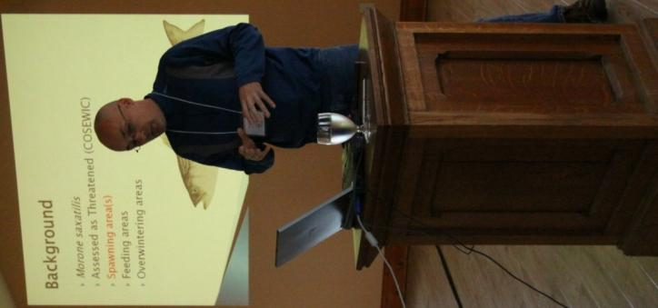
trevor.avery@acadiau.ca

Contributors:
Tom Labenski, Andrew Dal Cin, Chelsea Hammer, Elise Hebert, and Maja Reinhartsen

Canadian populations of striped bass (Morone saxatilis) are assessed as threatened and future management decisions may limit recreational angling, yet community-based organizations and individual anglers have seen recent increases in catches over the past decade. Some conflict of opinion on stock size exists between anglers and managers as the former rely on local, often individual-based, observations and the later on scientifically acceptable measures of population size and health. Historic creel censuses provide a glimpse into the effect of management decisions on stock dynamics and are grounded in surveys based on information gained from trained observers and interviews of local anglers. However, these surveys can contain bias depending on when and where they are conducted mitigating their use in stock assessments and management decisions. The inclusion of additional local ecological knowledge compiled from individual observations into an online database will increase both temporal and spatial catch and effort information that may have utility in stock assessment and management. We created an online repository for traditional creel census and socio-economic measures to gain further insights into the usefulness of steward-driven local ecological knowledge for assessment, management and socio-economic impact of striped bass recreational fisheries. Initial results and an overview of our approach is presented.
_________________________________________________________________________________________
Poster Session
Title: Fish Scales As Non-Lethal Biosensors Of Contaminants In Surface Waters: Preliminary Findings
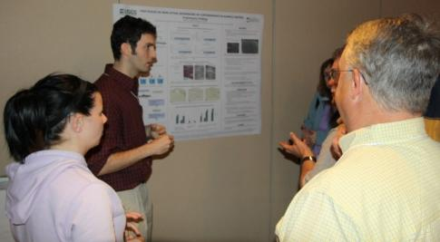
Primary Author:
Daniel Skall (Student)
University of Maine
5751 Murray Hall
The University of Maine
Orono, ME 04469-5751
daniel.skall@umit.maine.edu

Contributors:
A.A. Elskus, U.S. Geological Survey, Maine Field Office, University of Maine, Orono, ME 04469-5751

There is great need for non-lethal, biologically relevant screening tools for assessing the effects of surface water contaminants on threatened or endangered fish species. Typical screening procedures are highly invasive or lethal to the fish. Recent studies show that fish scales biochemically respond to a range of contaminants. I hypothesize that fish scales can serve as non-lethal, biologically relevant, rapid biosensors of fish response to contaminants. In preliminary experiments, in which I aqueously exposed Atlantic salmon (Salmo salar) parr to polychlorinated biphenyls and polynuclear aromatic hydrocarbons, I determined that the pollutant biomarker, cytochrome P4501A (CYP1A) is 1) inducible in S. salar scales, as measured by ethoxyresorufin-O-deethylase activity, and 2) is expressed in the epidermal covering of these scales, as shown through immunohistochemical analysis. I have also determined that ribonucleic acid (RNA) can be isolated from homogenized S. salar scales. These preliminary experiments demonstrate that the detection of organic contaminants using fish scales as biosensors is feasible. My next step is to establish quantitative (real-time) reverse-transcriptase polymerase chain reaction (qRT-PCR) assays to detect three contaminant classes: metals (mercury), endocrine disruptors (ethinyl-estradiol), and pharmaceuticals (fluoxetine), using scale metallothionein messenger RNA (mRNA), estrogen receptor mRNA, and CYP1A mRNA, respectively, as endpoints. A non-lethal fish biosensor would allow researchers and managers to determine if endangered fish species are being exposed to contaminants, in what part of their geographic range, and, for diadromous fishes, whether exposure is occurring during migration to-, or return from-, the sea. A non-lethal biosensor would also make it possible for samples to be taken at multiple time points from the same individual fish, allowing researches to investigate the time course and persistence of the fishs response to exposure. Support: USGS and the Senator George J. Mitchell Center for Environmental and Watershed Research 06HQGR0089

Title: Penobscot River Science Exchange: A Consortium for Dam Removal and Diadromous Fish Restoration Research

Primary Author:
Barbara S. Arter
Diadromous Species Restoration Research Network
PO Box 141
Steuben, ME 04680
bsarter@panax.com

Contributors:
Blaine Kopp, Penobscot River Restoration Trust

Covering 8,570 square miles, the Penobscot River is Maine's largest and New England's second largest watershed. Unfortunately, centuries of dam construction have blocked the migration of diadromous fish to their up-stream spawning and juvenile-rearing habitats, as well as altered the structure and function of fish assemblages throughout the river. The Penobscot River Restoration Project is a multi-million dollar endeavor to restore nearly 1,000 miles of sea-run fish habitat by removing two large hydro-electric dams in the lower part of the river and providing improved fish passage at a third dam upstream. In 2008, the Penobscot River Restoration Trust and agency and academic researchers began conducting studies and environmental monitoring on the river in order to establish pre-dam removal conditions that will allow managers to document restoration outcomes. This group of approximately 30 researchers makes up the Penobscot Science Exchange, which is a collaboration with the Diadromous Species Restoration Research Network (DSRRN), a five-year, NSF-funded collaborative research effort to advance the science of diadromous fish restoration. They meet twice annually to discuss river research plans and share results. This poster provides descriptions and graphics of research projects currently being conducted on the Penobscot in conjunction with the dam removals and the Penobscot Science Exchange. Projects include shortnose sturgeon movement and spawning, bird assemblages, sea lamprey movement in tributaries, iron-drainage impacts to water quality, alewife population structure and migration, marine-freshwater food web linkages, sea lamprey and Atlantic salmon interactions, and dam removal impacts on fish assemblages. The projects are also documented in the Penobscot River Annual Research Newsletter. For information about the newsletter, Exchange or DSRRN, please visit our website (www.umaine.edu/searunfish ) or contact the author at barbara.s.arter@umit.maine.edu or (207) 581-3286

Students

Jeremy Heather Murray Daniel

